Overall View

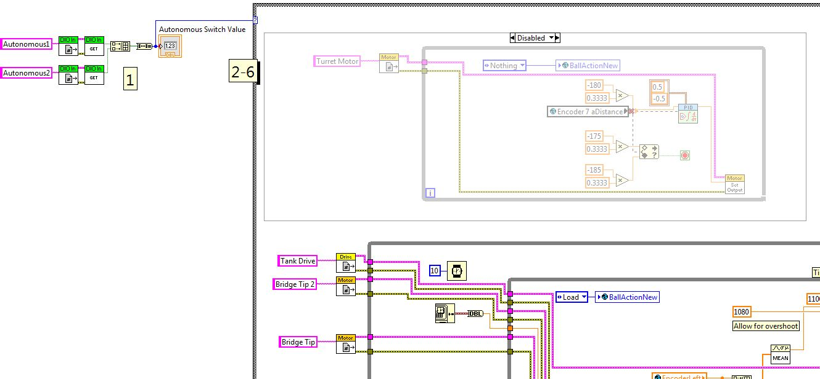

1. **Autonomous1(and2)DIO:** Gets the location of the potentiometers on the robots wiring system from **Begin.vi**. The values from each of the potentiometers is combined into an array, passed into a Boolean array to number conversion (binary numbers) and outputs a value between 0 and 3 to the output case structure.

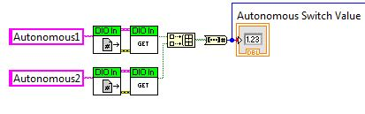

1. **Case Structure:** Gets the values from the potentiometer, selects the mode for the robot to shoot at in Autonomous mode.

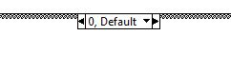

1. **Case 0:** The robot waits 4 seconds in autonomous then starts firing balls every 2 seconds based on a series of timers.



1. **Case 1:** The robot waits 10 seconds in autonomous then starts firing balls every 2 seconds based on a series of timers.

C:\Users\Feds201-1\Google Drive\Programming\Feds201 Manual\Images\AutonomousIndependent.VI\Case 1.JPG

1. **Case 2:** The robot shoots the balls it has after 4 seconds then runs to the bridge, gathers balls, goes back, and fires the remaining balls. (Incomplete, so don’t worry about this one).

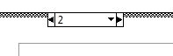

1. **Case 3:** The robot then runs to the bridge, gathers balls, goes back, and fires the balls that it has. (Incomplete, so don’t worry about this one).

**C:\Users\Feds201-1\Google Drive\Programming\Feds201 Manual\Images\AutonomousIndependent.VI\Case 3.JPG**

**Issues:**

* We tried to implement a program in which the code was built ground up without using any of the already written code, such as functions from **BallLoader.vi.** This created conflict on the robot, confusing it on which instructions it should obey from two different VI’s.
* Took a long time to implement the timings, you need to count every millisecond to be accurate. The **Get Date and Time in Seconds** function is very useful, use it to get differences in times and run a piece of code at certain intervals, etc.

**Tips:**

* To sequence events, use a series of while loops. Wire any term through them, such as the **interval counter (the blue i)**, or the error term from one of the VI blocks.